Bursary Mashinani Portal User Manual

Landing Page:
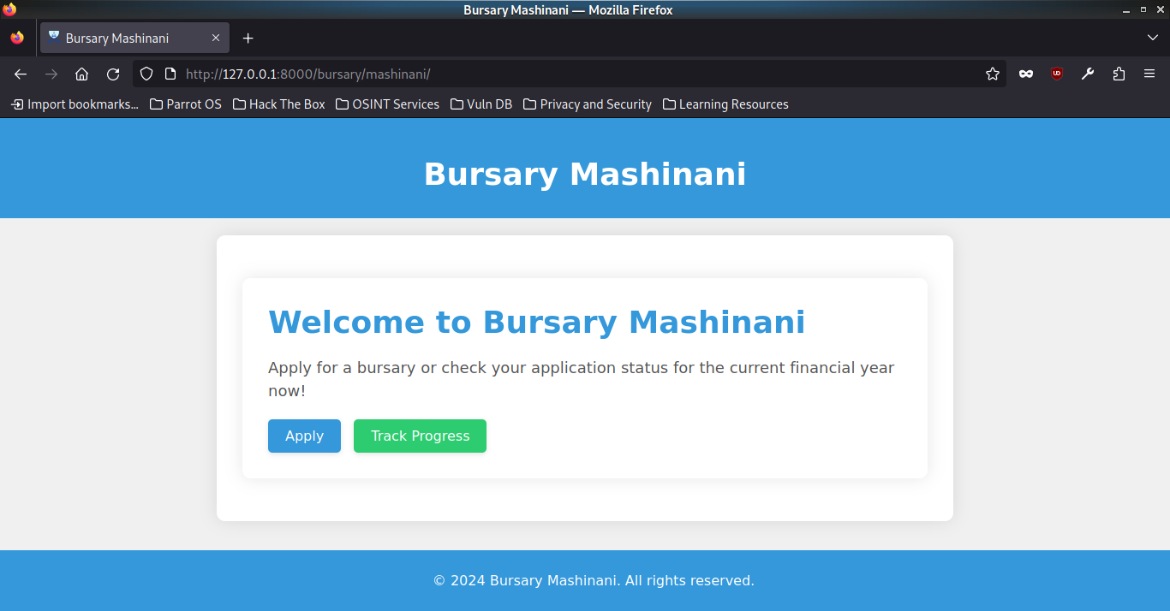

User Interaction:
- Navigate to the Bursary Mashinani portal.
- Display the current bursary application status for the financial year.
- Options available: "Apply" (Blue Button) and "Track Progress" (Green Button).

Apply for Bursary:
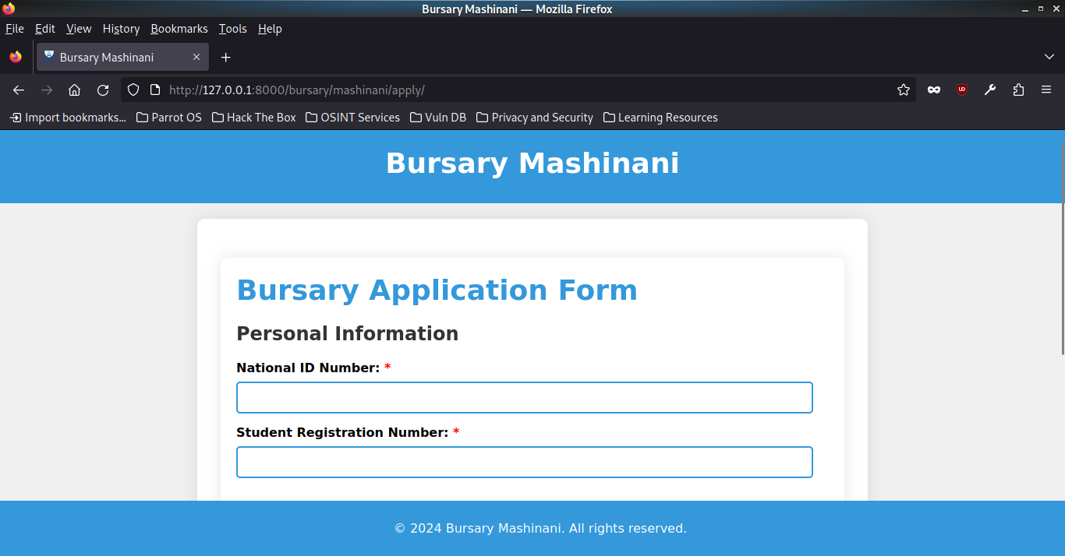

User Interaction:
- Click on the "Apply" button to redirect to the application page.
- Choose Tertiary Institution type from the Dropdown with Blue Border.
- Proceed to the final page for entering personal details.
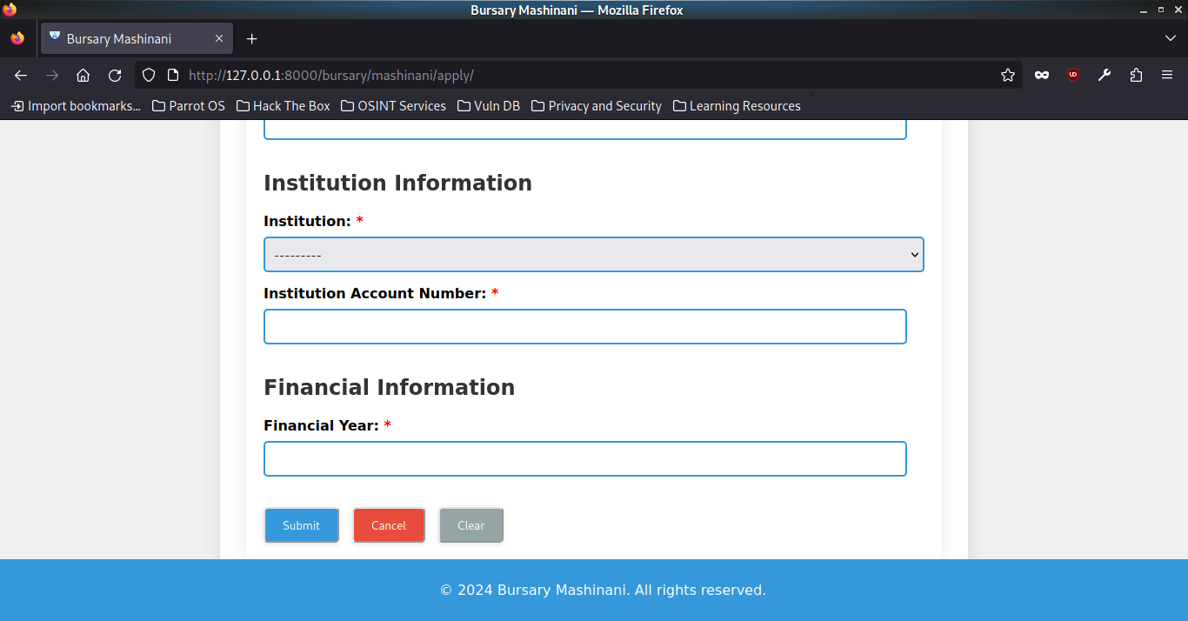

Personal Details Page:

User Interaction:
- Enter the following information:
  - Valid National ID Number (Blue Input Box).
  - Valid Student Registration Number (Blue Input Box).
  - Valid Institution Name (Dropdown with Blue Border).
  - Valid Institution Account Number (Dropdown with Blue Border).

Application Validation:

System Process:
- Check the validity of the entered National ID and Student Registration Number.
- Verify eligibility and registration as a voter in Kisumu West Constituency.
- Validate against the current students register of the chosen institution for the given academic year.
- Display appropriate error messages (Red Text) for incorrectly filled fields.
- Ensure that the National ID and Student Registration Number can only be used once per financial year.

Submission Options:

User Interaction:
- Click the "Submit" button (Green Button) to complete the application process.
- Click "Cancel" (Red Button) to abort the application.
- Use the "Clear" button (Gray Button) to undo filled fields.
- Submission is not allowed if any field is empty; validation errors must be addressed before submission.

Application Success:

System Process:
- Upon successful submission, generate a unique 8-alphanumeric character serial number.
- Encrypt the serial number using the RSA encryption algorithm before storing it in the database.
- Display a success message (Green Text) including the decrypted serial number.
- Allow the user to save the serial number as PNG or PDF for future reference.

Track Progress:
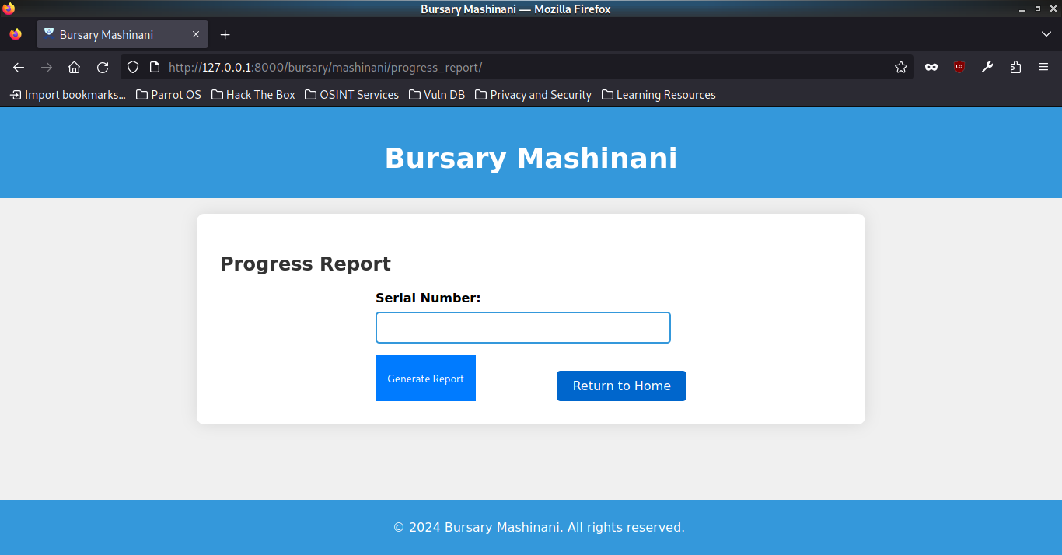

User Interaction:
- Click "Track Progress" (Green Button) to redirect to a page for entering the serial number.

Progress Tracking Page:

User Interaction:
- Enter the 8-alphanumeric serial number generated during the application.
- Check if the serial number matches records in the Successful Applications database.

Generate Report:

System Process:
- If a match is found, generate a report with the following details:
  - Valid Student Name.
  - Valid Student Registration Number.
  - Valid Institution Name.
  - Amount Disbursed in Ksh.
  - Date Disbursed.

Report Options:

User Interaction:
- Save the report as a PDF (Blue Button) for future reference.
- Display appropriate error message (Red Text) if the serial number is not found or is invalid.
- Redirect the user to the landing page.

UI/UX Recommendations:
- Use a clean and simple design with a blue and white color scheme.
- Differentiate interactive elements with distinct colors (Green for positive actions, Red for negative actions).
- Provide clear and concise error messages in red for better visibility.
- Use intuitive icons for actions like submit, cancel, and clear.
- Ensure a responsive design for a seamless user experience across devices.
- Include progress indicators (Blue Progress Bar) during lengthy processes.
- Use tooltips or info icons for guiding users through complex processes.
- Implement a user-friendly font (Arial or Roboto) and ensure proper spacing for readability.
- Optimize the layout for easy navigation between sections.

